# **CTF Topic: Footprinting and Reconnaissance.**

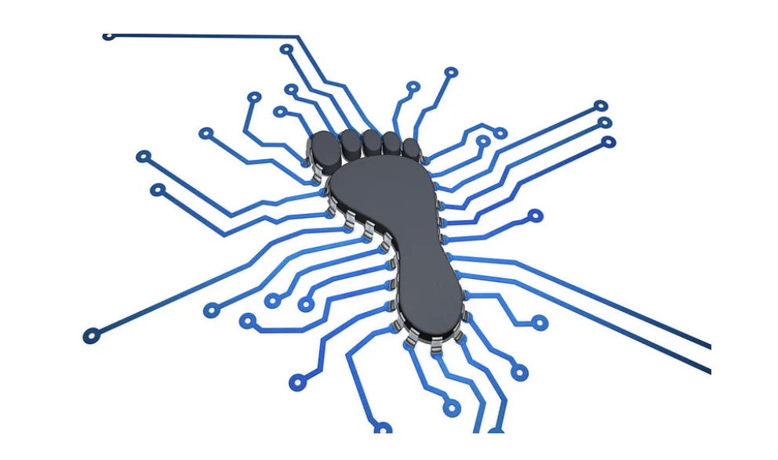

# **1. Introduction**



Footprinting and reconnaissance involve gathering detailed information about a target system using both passive and active methods to identify vulnerabilities for penetration testing. These phases are essential for planning effective security assessments and ensuring robust defenses.

# **2. Tools and requirements**

Operating Systems.

# **3. Scenario**



A recent video on YouTube went viral 2 days ago. This video created a negative impact on society. The Cybersecurity team wants to know when the video was published and more about the video.

# **4. Process to perform while performing CTF**

Go to the video given on the Link_1 and copy the link of the video and paste on the search bar after going on the link_2.

Link_1: <https://www.youtube.com/watch?v=OGTXBSQ1ilI>

Link_2: <https://mattw.io/youtube-metadata/>

# **Question**

**Flag 1: What is the link to open the metadata page?**

**Answer:** [**https://mattw.io/youtube-metadata/**](https://mattw.io/youtube-metadata/)

**Flag Captured.**

**Flag 2: What is the date when the video was published?**

**Answer: 2024-06-04**

**Flag Captured.**

**Flag 3: What are the dimensions of content details?**

**Answer: 2**

**Flag Captured.**

# **Hint**